Student1: Enter name here.

Student2: Enter name here.

CMSC 508 - Spring 2018

Homework 1

1. For these instances of two relations in a banking database, indicate the following:

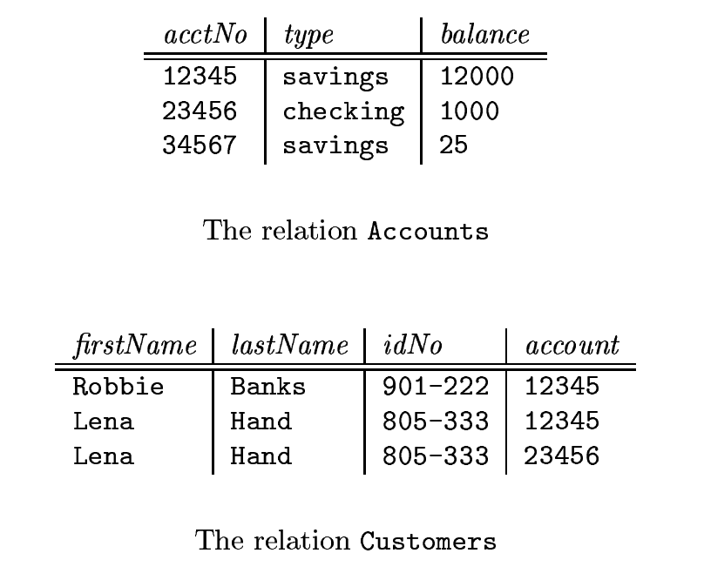

1. The attributes of each relation.
2. The tuples of each relation.
3. The relation schema for each relation.
4. The database schema.
5. A suitable domain for each attribute.
6. Please answer in your own words.
   1. Explain the concept of physical data independence, and its importance in database systems.
   2. What is a transaction? Define ACID and provide a brief description of each.
   3. What is integrity? Describe two ways to enforce integrity in a database.
   4. Differentiate between an entity and an entity set.
   5. Differentiate between a relation and a relationship. Can a relationship be represented by a relation?
   6. What is the difference between a super key, a candidate key, and a primary key?
7. Draw an entity-relationship diagram for each of the following data sets. Remember to identify keys and to label relationships with their functionality. If you have to make any assumptions in order to decide what to draw, then state those assumptions. Think carefully about what is an entity, what is a relationship and what is an attribute. Sometimes things sound like one but are better represented in another way.
   1. Doug’s Dog Walking Service has grown from a part-time venture for earning beer money to a big business. (It seems like everyone in Richmond has a dog these days.) Doug needs a database to keep track of his clients and their beloved pet(s). Data is to be stored about clients, dogs, and walking history (track record, if you will). This data includes the animals name, date of birth, breed of dog, owner, and the dog’s exercise history. Data to be stored about owners includes name, address, and phone number. Data stored about the exercise history is: which dog went for a walk, date walked, length of the walk, and the charge to the owner. Doug is expanding his business and has hired some employees as dog walkers, so he’d like you to include some employee information, too. Data stored about each employee is their name, address, and phone number, along with which dogs they exercised, and when they did so.
   2. Ultimate Hair salon has offered you free life-time haircuts if you design its database schema. Given the rising cost of personal care and your impeccable sense of style, you agree. Here is the information that you gathered: Clients are identified by their unique customer loyalty card number, and we also store their names and age. Stylists are identified by their employee ID number, and we also store their names and specialty. Each patient has one preferred stylist, and we want to know how long the client has been with her preferred stylist. Each stylist has at least one client.
8. For the following E/R diagram, provide the relational database schema that you would create for the database.

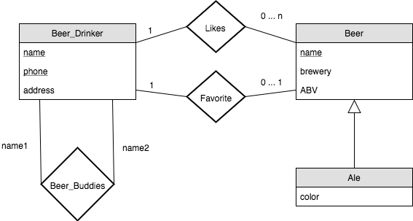

0 … 1

0 … 1